Jeremy Scheuerman

Dr. Peter Wang

Lab 3

3.1

1. 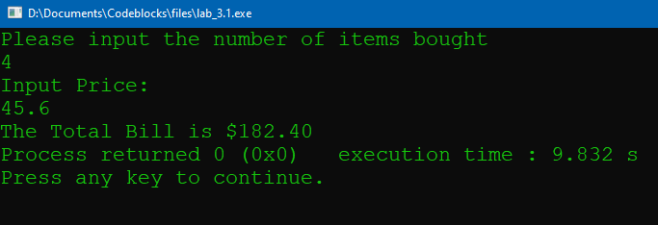

2. The fixed statement puts the number in fixed notation

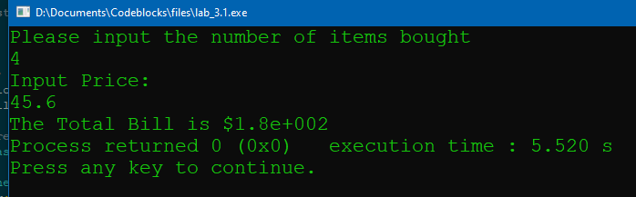

3.changes it to 4 decimal places

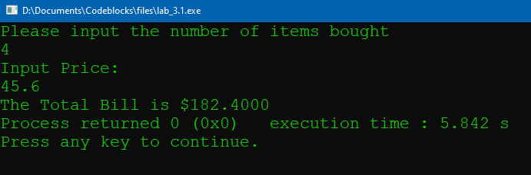

4. 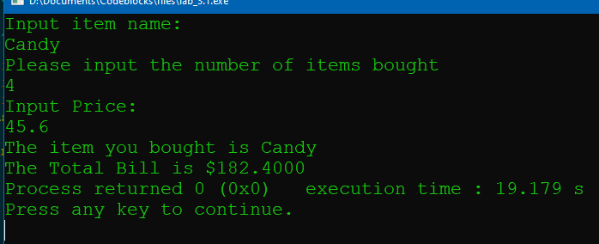

// This program will read in the quantity of a particular item and its price.

// It will then print out the total price.

// The input will come from the keyboard and the output will go to

// the screen.

// PLACE YOUR NAME HERE

#include <iostream>

#include <iomanip>

#include <string>

using namespace std;

int main()

{

int quantity; // contains the amount of items purchased

float itemPrice; // contains the price of each item

float totalBill; // contains the total bill.

string name; //item name

cout<<"Input item name: "<<endl;

getline(cin,name);

cout << setprecision(4) <<fixed<< showpoint; // formatted output

cout << "Please input the number of items bought" << endl;

// Fill in the input statement to bring in the quantity.

cin>>quantity;

// Fill in the prompt to ask for the price.

cout<< "Input Price: "<<endl;

cin>>itemPrice;

// Fill in the input statement to bring in the price of each item.

// Fill in the assignment statement to determine the total bill.

totalBill=itemPrice*quantity;

// Fill in the output statement to print total bill,

cout<<"The item you bought is "<<name<<endl;

cout<<setprecision(4)<<fixed<<showpoint<<"The Total Bill is $"<<totalBill;

// with a label to the screen.

return 0;

}

3.2

1. 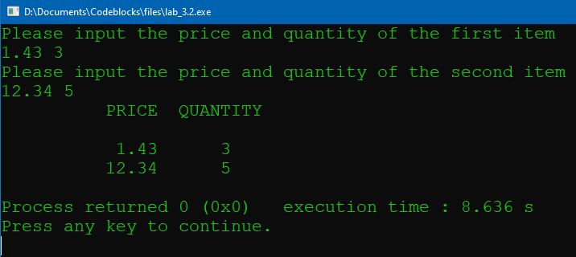

// This program will bring in two prices and two quantities of items

// from the keyboard and print those numbers in a formatted chart.

//PLACE YOUR NAME HERE

#include <iostream>

#include <iomanip>

// Fill in the code to bring in the library for

// formatted output.

using namespace std;

int main()

{

float price1, price2; // The price of 2 items

int quantity1, quantity2; // The quantity of 2 items

cout << setprecision(2) << fixed << showpoint;

cout << "Please input the price and quantity of the first item" << endl;

// Fill in the input statement that reads in price1 and

// quantity1 from the keyboard.

cin >>price1>>quantity1;

// Fill in the prompt for the second price and quantity.

cout << "Please input the price and quantity of the second item" << endl;

// Fill in the input statement that reads in price2 and

// quantity2 from the keyboard.

cin >>price2>>quantity2;

cout << setw(15) << "PRICE" << setw(12) << "QUANTITY\n\n";

cout << setw(15) << price1 << setw(7) << quantity1<<"\n";

// Fill in the output statement that prints the first price

// and quantity. Be sure to use setw() statements.

cout << setw(15) << price2 << setw(7) << quantity2<<"\n";

// Fill in the output statement that prints the second price

// and quantity.

return 0;

}

3.3

1. 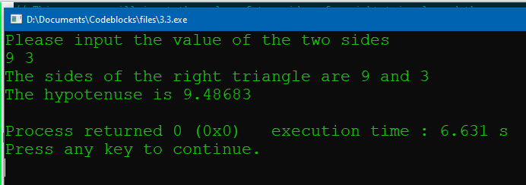

2. 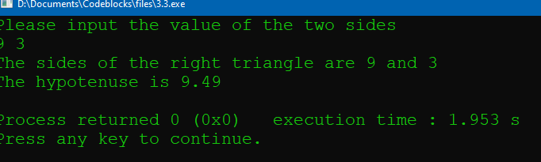

// This program will input the value of two sides of a right triangle and then

// determine the size of the hypotenuse.

// PLACE YOUR NAME HERE

#include <iostream>

#include <cmath> // needed for math functions like sqrt()

using namespace std;

int main()

{

float a, b; // the smaller two sides of the triangle

float hyp; // the hypotenuse calculated by the program

cout << "Please input the value of the two sides" << endl;

cin >> a >> b;

// Fill in the assignment statement that determines the hypotenuse

hyp=sqrt(pow(a,2)+pow(b,2));

//hypot could also be used

cout << "The sides of the right triangle are " << a << " and " << b << endl;

cout << "The hypotenuse is " << floor(hyp*100+0.5)/100 <<'\n';

return 0;

}

3.4

1. 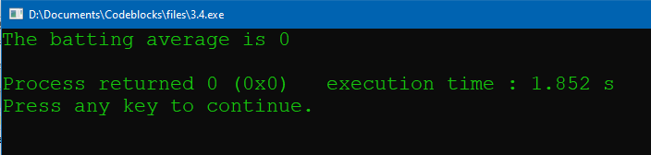

2. 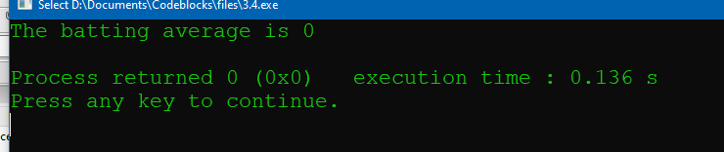

Same output

3. 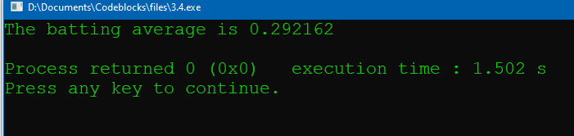

// This program will determine the batting average of a player.

// The number of hits and at bats are set internally in the program.

// PLACE YOUR NAME HERE

#include <iostream>

using namespace std;

const int AT_BAT = 421;

const int HITS = 123;

int main()

{

float batAvg;

batAvg =(float) HITS / (float) AT_BAT ; // an assignment statement

cout << "The batting average is " << batAvg << endl; // output the result

return 0;

}

3.5

1. 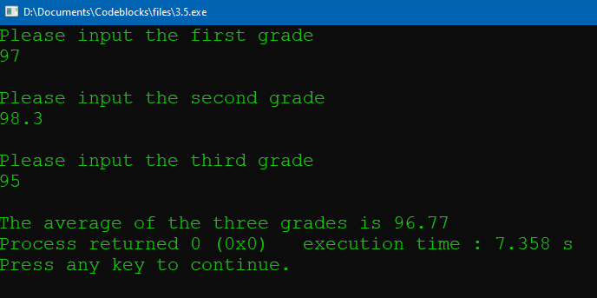

//jeremy scheuerman

#include <iostream>

#include <iomanip>

using namespace std;

int main()

{

float grade_1;

float grade_2;

float grade_3;

float grade_avg;

//init

cout << setprecision(2) << fixed << showpoint;

cout <<"Please input the first grade " << endl; // output the result

cin>>grade_1;

cout <<"\nPlease input the second grade " << endl; // output the result

cin>>grade_2;

cout <<"\nPlease input the third grade " << endl; // output the result

cin>>grade_3;

grade_avg=(grade_1+grade_2+grade_3)/3;

cout<<"\nThe average of the three grades is "<<setprecision(2)<<grade_avg;

return 0;

}